**Course Project –** [**Create a Visualization Map**](https://learning.rasmussen.edu/webapps/assignment/uploadAssignment?content_id=_6076869_1&course_id=_67422_1&group_id=&mode=view)

Shaun Pritchard

Rasmussen College

QMB3300

Jerome Olorunmaiye

June 12, 2020

**Course Project –** [**Create a Visualization Map**](https://learning.rasmussen.edu/webapps/assignment/uploadAssignment?content_id=_6076869_1&course_id=_67422_1&group_id=&mode=view)

To show an infographic to bring awareness of energy consumption in my home state of Florida I will use specific variable to tell my story.

1. Facts
2. Sectors
3. Sources of energy consumption
4. Production
5. Show
6. Residential end use
7. Conclusion and call to action for awareness

**Visualization infographic overview**

* The first visualizations I will show will facilitate specific facts on wear for Indians and the people in the state of Florida I currently at as far as energy consumption is concerned.
* I will then break down the specific sectors such as residential, commercial, industrial, and transportation. From this I will show the different uses and consumption levels in each of these categories.
* Then I will break down the different sources of energy consumption into the different groups and methods we used to produce and consume energy in Florida.
* From here I could show some visualizations of which sources we are overusing and renewable sources that we should be implementing in using more of.
* After that I will show the production of energy which will tie into the fax in the first visualizations. Based on how Florida is number four in America for consuming energy. But is number 5 from last per capita for consuming energy.
* I will then do a final breakdown of the residential and use showing the different devices, appliances, and uses of energy consumption to give the viewer a visualization that could be applicable to the viewer themselves. I do this diet showing that air conditioning for instance is the most widely consumed resource in Florida. This can give rise to the incentive of just trying to collaborate and come together to find new ways to cool our homes like insulation and productivity.
* Then I will do my final conclusion and my call to action for awareness. Highlighting some ideas on being more conservative with energy tying in everything including the infographic altogether

A full version of the info graph and data can be viewed online here:

<https://www.canva.com/design/DAD_Q34J_EY/k23b5rc_ISvrlNtDP5F2TQ/view?utm_content=DAD_Q34J_EY&utm_campaign=designshare&utm_medium=link&utm_source=sharebutton>

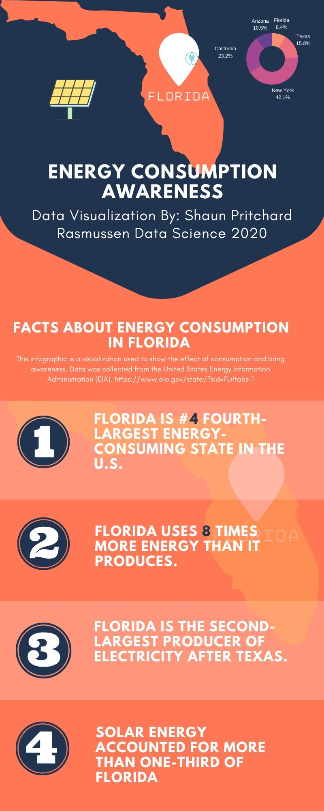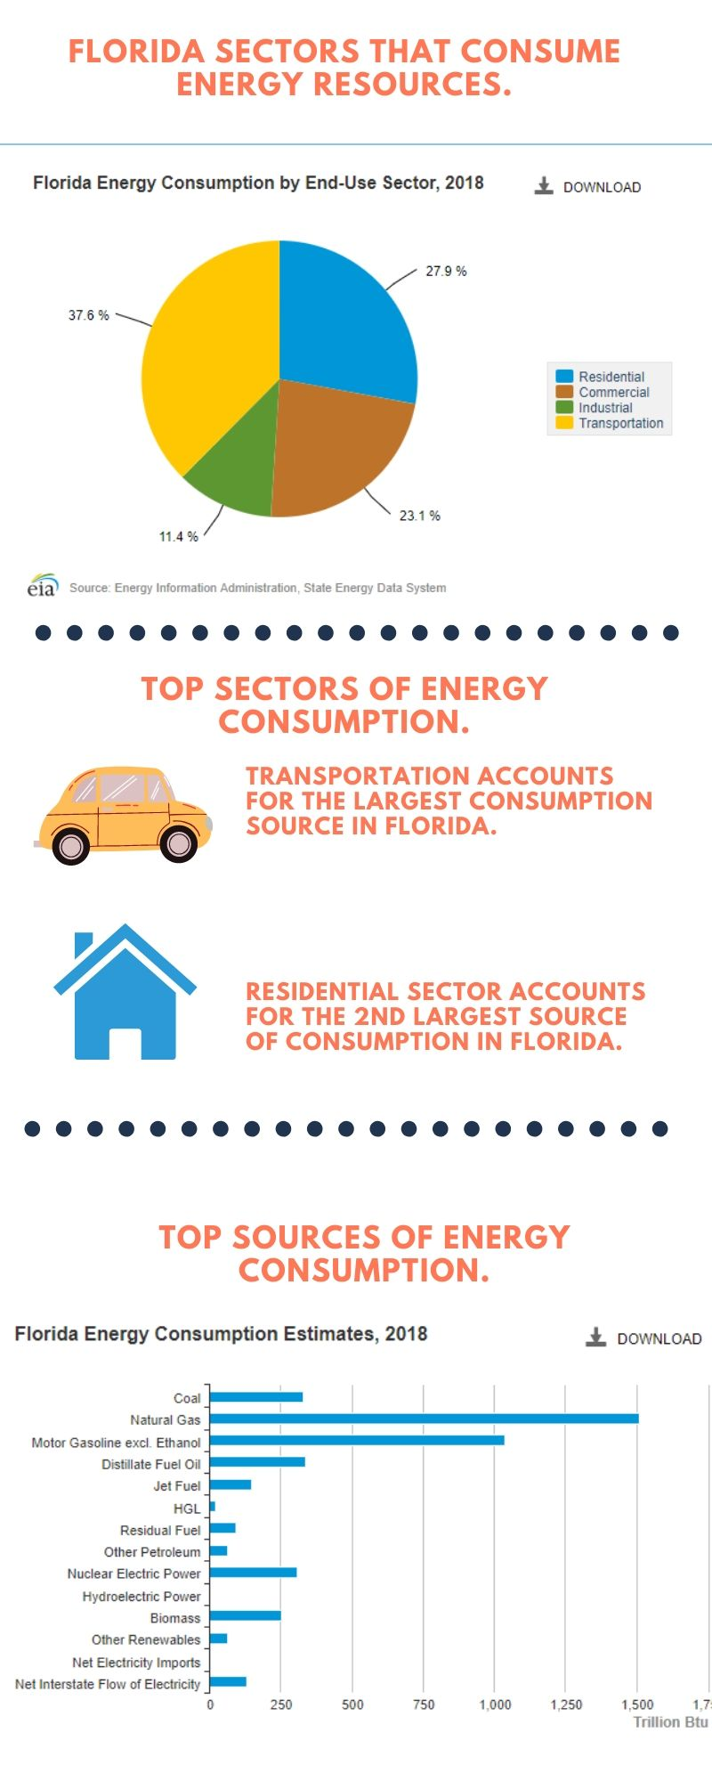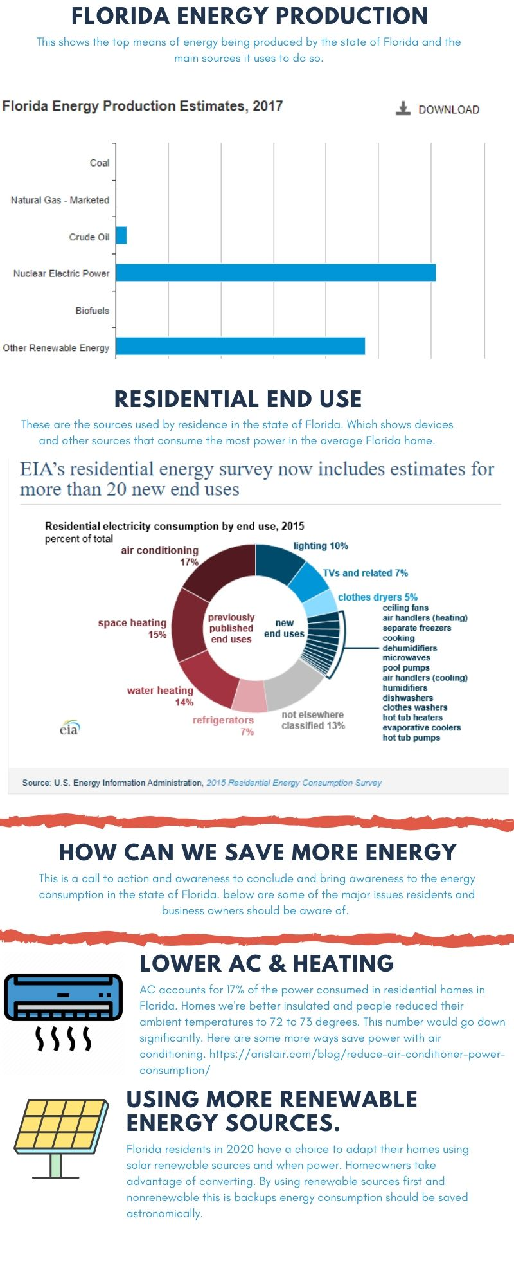

We find that since Florida consumes more power than States like Texas rating at number 2 by the EIA for energy consumption. The data also shows us that Florida residence and transportation needs consume a lot of power. This way to invite a call to action to use more renewable power sources, implement more technology for less consuming transportations, use better technology in our homes, and to bring awareness to people to try to lower power consumption usage.

Florida is a big Tourist state, I think the problem lies within tourists coming here and consuming power as they do back home with our regard or knowledge of this state’s issues. It also states that we consume more power than we produce yet we produce 8 times as much power than the top states in the U.S using more power sources than any other state.